{RBG.AI }

{EmoChat Guard}

A White Paper

Team Name : DELTA

{02/03/2024}

Introduction / Background
In today's globalized landscape, effective communication in multilingual emergency situations is crucial. Our solution integrates advanced technologies like translation and speech recognition to swiftly extract vital information from diverse linguistic calls. It prioritizes distress levels and segments speakers, resulting in clear and actionable reports for law enforcement. By enhancing communication and decision-making, it significantly improves response times to critical incidents. Its streamlined application ensures improved public safety and crisis management in various linguistic contexts. Our approach stands as a reliable solution for law enforcement agencies globally, addressing the urgent need for efficient emergency call processing.

Problem Statement / Introduction
Law enforcement agencies encounter challenges in efficiently processing multilingual emergency calls, hindering timely response efforts. Existing systems lack a comprehensive approach to handling voice data, including translation, transcription, summarization, and distress analysis. This gap delays crucial information extraction, hampers communication, and impedes swift action during critical incidents. Our solution aims to address these issues by developing an end-to-end AI system that seamlessly translates, transcribes, summarizes, and analyzes distress levels in emergency calls, facilitating quicker and more effective responses for police authorities. The integration of speaker segmentation ensures clarity and context in the generated reports, enhancing overall communication and decision-making processes.

Abstract / Business Case
Our solution responds to the complexity of multilingual emergency calls for law enforcement by seamlessly integrating advanced translation, automatic speech recognition, summarization, and distress analysis technologies. This comprehensive approach allows for the rapid extraction of crucial information, prioritization of distress levels, and organized segmentation of speakers, resulting in clear and actionable reports. By enhancing communication, expediting decision-making, and providing valuable insights, our solution ensures a more efficient response to critical incidents. Its streamlined application in emergency call processing significantly contributes to improved public safety and crisis management, meeting the urgent needs of law enforcement in diverse linguistic contexts.

Proposed Solution(s)

Introduction of Solution
In the dynamic landscape of emergency response, effective communication plays a pivotal role in ensuring swift and accurate interventions. Our innovative solution addresses the complexities of multilingual emergency calls by seamlessly integrating advanced technologies. Through the integration of cutting-edge translation and speech recognition technologies, alongside audio enhancement and noise cancellation techniques, we enable the accurate interpretation and transcription of diverse linguistic calls. This facilitates the swift extraction of vital information, aiding in the prioritization of distress levels and segmentation of speakers. Moreover, our solution goes beyond mere transcription by generating comprehensive reports in both English and Tamil, providing law enforcement agencies with actionable insights for informed decision-making.

Application of Solution
Our solution has several practical applications in the realm of emergency response and law enforcement. Firstly, it results in the creation of clear and actionable reports, providing crucial insights for law enforcement agencies to act upon swiftly. Additionally, it enhances communication channels and aids in better decision-making processes during critical incidents. This improvement in communication and decision-making ultimately leads to significant reductions in response times, allowing for more efficient handling of emergencies. Furthermore, the streamlined application of our solution ensures overall improvements in public safety and crisis management efforts. By addressing the urgent need for efficient emergency call processing, our solution contributes to smoother operations and more effective outcomes in diverse linguistic contexts.

5.Future Direction / Long-Term Focus

Our future enhancement idea for this project includes improving linguistic models to understand various languages worldwide and convert reports into any desired language. Additionally, we aim to enhance accuracy and add legal documentation provisions with higher security measures for saving reports in a police database.

6. Results / Conclusion
Our model excels in audio enhancement and noise cancellation, ensuring optimal clarity. Moreover, its speaker diarization capabilities effectively identify the number of speakers in the audio. With a remarkable 99% accuracy rate, the model conducts sentiment analysis seamlessly. Additionally, it efficiently recognizes and translates various regional languages into English. Most importantly, it swiftly extracts vital information from the audio, presenting detailed reports that encapsulate the conversation within.

Appendices

Appendix A – Workflow Diagram
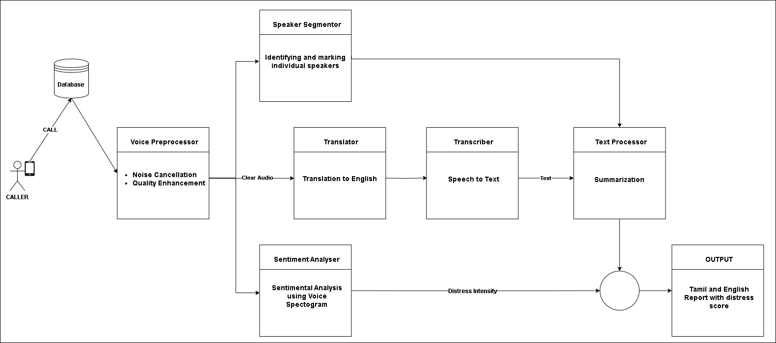

Appendix B – Workflow Algorithms & Models Used
- Preprocessing : In our project, preprocessing techniques are utilized specifically for audio enhancement and noise reduction. This involves applying Gaussian filtering to remove background noise and enhance the clarity of audio recordings.

- Voice Diarization : Our project utilizes voice diarization to partition audio recordings into segments corresponding to different speakers. This enables the identification and separation of individual speakers' voices, facilitating more accurate transcription and analysis of spoken content.

- Translation : We utilizes the MBart model for translating text from Tamil to English. It employs the MBartForConditionalGeneration model and MBart50TokenizerFast for tokenization. Translation is performed using forced beginning-of-sequence and end-of-sequence tokens corresponding to the source and target languages. The translated text is then decoded and analyzed for sentiment using the specified function.

- Transcription : Transcription, empowered by libraries like librosa for audio processing and speech_recognition for speech recognition, converts audio recordings into textual format. This text-based analysis facilitates enhanced search, indexing, and extraction of valuable insights from audio data, contributing to various applications without relying on external APIs.

- Sentiment Analysis : Sentiment Analysis implements a binary classification model using audio features extracted from fear and non-fear audio files. It first extracts features like MFCC, chroma, and mel spectrograms from the audio files. Then, it constructs a neural network model using TensorFlow's Keras with dense layers. The model is trained on the extracted features, compiled with binary cross-entropy loss, and evaluated on test data. This approach enables the classification of fear and non-fear audio samples based on their extracted features, providing insights into emotional content detection from audio data.

- Summarization : The `summarizer` function utilizes a pre-trained summarization pipeline from the Hugging Face Transformers library to generate concise summaries of input text. It combines these summaries with sentiment and confidence scores, along with audio sentiment analysis results, to provide comprehensive insights into the input text's content.

Appendix D – Team Members Contribution
Thamizh - Preprocessing
Vishva - Segmentation
VijayKarthick - Translation
Sriram - Summarization
Janaranjan E – Voice Sentiment Analysis Model
SriHari - LLM
Shanmugavasan - Integration and fine-tuning, Text Sentiment

